### 

### Semester One Examination, 2022

### Question/Answer booklet

# MATHEMATICS METHODS

**UNIT 3**

## Section Two:

## Calculator-assumed

|  |  |
| --- | --- |
| **Your Name:** |  |
| **Your Teacher’s Name:** |  |

## Time allowed for this section

Reading time before commencing work: ten minutes

Working time: one hundred minutes

## Materials required/recommended for this section

***To be provided by the supervisor***

This Question/Answer booklet

Formula sheet (retained from Section One)

***To be provided by the candidate***

Standard items: pens (blue/black preferred), pencils (including coloured), sharpener, correction fluid/tape, eraser, ruler, highlighters

Special items: drawing instruments, templates, notes on two unfolded sheets of A4 paper, and up to three calculators approved for use in this examination

## Important note to candidates

No other items may be taken into the examination room. It is **your** responsibility to ensure that you do not have any unauthorised material. If you have any unauthorised material with you, hand it to the supervisor **before** reading any further.

|  |  |  |  |  |  |
| --- | --- | --- | --- | --- | --- |
| Question | Marks | Max | Question | Marks | Max |
| 7 |  | 8 | 13 |  | 11 |
| 8 |  | 15 | 14 |  | 12 |
| 9 |  | 8 | 15 |  | 10 |
| 10 |  | 8 | 16 |  | 8 |
| 11 |  | 10 |  |  |  |
| 12 |  | 10 |  |  |  |

**Structure of this paper**

|  |  |  |  |  |  |
| --- | --- | --- | --- | --- | --- |
| Section | Number of questions available | Number of questions to be answered | Working time (minutes) | Marks available | Percentage of examination |
| Section One:  Calculator-free | 6 | 6 | 50 | 53 | 35 |
| Section Two:  Calculator-assumed | 10 | 10 | 100 | 100 | 65 |
|  |  |  |  | **Total** | 100 |

**Instructions to candidates**

1. The rules for the conduct of the Western Australian Certificate of Education ATAR course examinations are detailed in the *Year 12 Information Handbook 2019*. Sitting this examination implies that you agree to abide by these rules.
2. Write your answers in this Question/Answer booklet.
3. You must be careful to confine your answers to the specific questions asked and to follow any instructions that are specific to a particular question.
4. Additional pages for the use of planning your answer to a question or continuing your answer to a question have been provided at the end of this Question/Answer booklet. If you use the space to continue an answer, indicate in the original answer space where the answer is continued, i.e. give the page number.
5. **Show all your working clearly.**Your working should be in sufficient detail to allow your answers to be checked readily and for marks to be awarded for reasoning. Incorrect answers given without supporting reasoning cannot be allocated any marks. For any question or part question worth more than two marks, valid working or justification is required to receive full marks. If you repeat any question, ensure that you cancel the answer you do not wish to have marked.
6. It is recommended that you **do not use pencil**, except in diagrams.
7. The Formula sheet is **not** to be handed in with your Question/Answer booklet.

**Section Two: Calculator-assumed (100 Marks)**

This section has **ten** questions. Answer **all** questions. Write your answers in the spaces provided.

Spare pages are included at the end of this booklet. They can be used for planning your responses and/or as additional space if required to continue an answer.

● Planning: If you use the spare pages for planning, indicate this clearly at the top of the page.

● Continuing an answer: If you need to use the space to continue an answer, indicate in the original answer space where the answer is continued, i.e. give the page number. Fill in the number of the question that you are continuing to answer at the top of the page.

Working time: 100 minutes.

**Question 7 (8 marks)**

<EFOFEX>
id:fxd{c2fae747-cec1-4d2d-9d42-265f6304d397}

FXData:
</EFOFEX>

The graphs of the continuous functions and   
are shown at right.

(a) Evaluate the derivative of at . (2 marks)

(b) Evaluate the derivative of at . (3 marks)

(c) Evaluate the derivative of at . (3 marks)

**Question 8 (15 marks)**

The profit function, in $, of a company producing items, is given by:

1. Interpret the value of in this context. (1 mark)
2. Use Calculus methods to determine the maximum profit. (4 marks)
3. Find the marginal profit when and explain what this value predicts. (3 marks)
4. State the maximum marginal profit and when this occurs. (3 marks)
5. How many items must be produced to ensure a profit? (2 marks)

1. Determine the average profit when . (2 marks)

**Question 9 (8 marks)**

Ryan and Oliver play a game where two normal six-sided dice are rolled, the uppermost number noted and then a third six-sided die is rolled. To win the game the number rolled on the third die must fall **between** the numbers rolled on the first two dice. For example, if a 2 and a 5 are the rolled on the first two dice, to win the game a 3 or a 4 must be rolled on the third dice.

1. Determine the probability that a player has no chance of winning before even rolling the third die.

(HINT: Showing the sample space is helpful) (3 marks)

1. Let the random variable, , be the number of numbers between the first two dice. Complete the probability distribution table below. (2 marks)

|  |  |  |  |  |  |
| --- | --- | --- | --- | --- | --- |
|  |  |  |  |  |  |
|  |  |  |  |  |  |

1. Determine the probability that a player wins the game. (3 marks)

Question 10 (8 marks)

The mining town of Clipalmerton has been experiencing population exponential growth over the last decade.

(i.e.  where  is the population at years)

The population of the town 10 years ago was 10 000, and there are now (at the beginning of 2022) an extra 1600 people living in the town.

1. Assuming the model of exponential growth remains the same in the future, use this information to write an equation to predict the population, , of Clipalmerton years from the beginning of 2022.

(3 marks)

1. Hence predict the population of Clipalmerton at the beginning of 2030. (1 mark)
2. The nearby town of Scomotown has also been growing, but its population growth has been such that the equation to predict its population in years’ time (from the beginning of 2022) is:
3. What is the current population of Scomotown (at the beginning of 2022)? (1 mark)
4. During which years will the population of Scomotown be greater than the population of Clipalmerton? (3 marks)

Question 11 (10 marks)

(a) Given the variance of a Bernoulli distribution is 0.2176, determine the mean. (2 marks)

(b) The probability of success of a Bernoulli trial is p. Given that it is repeated n times, the expected value and variance of the resulting distribution of the number of successes are 7.52 and 3.9856 respectively. Determine n and p. (4 marks)

(c) The probability of Jeremy being late to his Maths class is 0.3, and the probability that he is late to his Maths class on any day is independent of whether he was late on the previous day.

Over five consecutive weekdays, what is the probability that Jeremy

(i) is only late to his Maths class on Tuesday? (1 mark)

(ii) is late on Tuesday and on at least two other days? (3 marks)

Question 12 (10 marks)

A square based prism as shown in the diagram has a hemisphere added to its top in such a way that the diameter of the hemisphere is the same as the width of the box. The volume () of the object is 800 cm3.

*x*

*x*

*y*

(a) Determine in terms of and . (1 mark)

(b) Show that the value of y is given by (2 marks)

(c) Show that the surface area of the shape, , is given by (3 marks)

(d) Using calculus to justify your answer, determine the minimum possible surface area of the prism and the value of for which it occurs. (4 marks)

**Question 13 (11 marks)**

Consider the graph below:

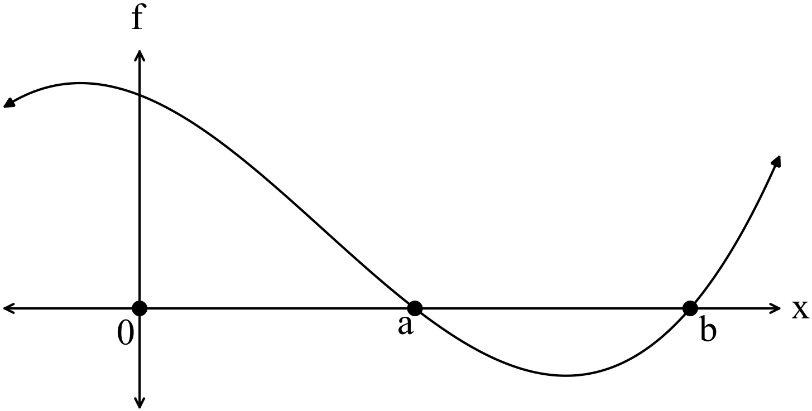

1. Given and
2. Evaluate  (2 marks)

1. Determine the area bounded by the function, the - axis and - axis on the interval 

(2 marks)

**Question 13 (Continued)**

The function  is graphed below.

b)

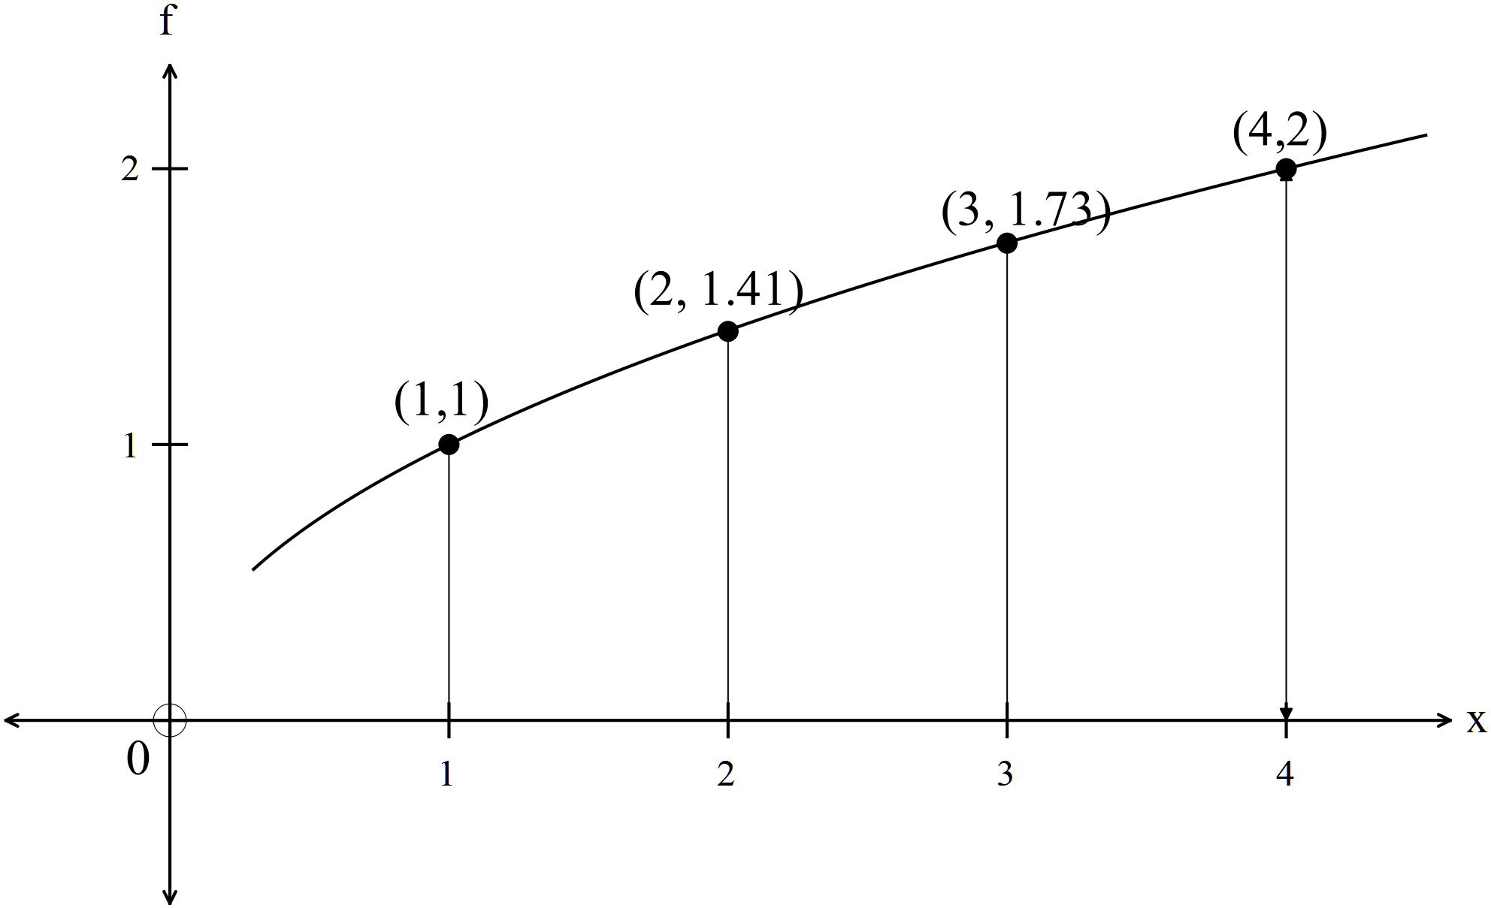

1. Using rectangles from above and from below, find an estimate for the area between the function, and theaxis. Use as the width of the interval.

(5 marks)

(ii) Use integration to evaluate the exact area estimated in (i). (2 marks)

Question 14 (12 marks)

Dezz installs outdoor security lights that are connected to a system which has been configured so that all the lights will turn on if their sensors detect motion. The system will continue to work if at least three of the lights are working. There is a 6% chance that any light fails. If the random variable is the number of lights that fail,

1. State the distribution of , including its parameters, and state two assumptions that were required to use this distribution. (4 marks)
2. If the variance of is ,
   1. Determine the number of lights that have been used. (2 marks)
   2. What is the probability that less than half the lights fail given more than 1 light failed? (2 marks)
   3. What is the probability that the system fails? (2 marks)
3. One night, Dezz removes two of the lights so that they can be repaired. The lights are not replaced for the next night. What is the probability that the system works for that night?

(2 marks)

Question 15 (10 marks)

The displacement in metres, 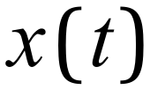, of a particle t seconds after it was launched is given by:

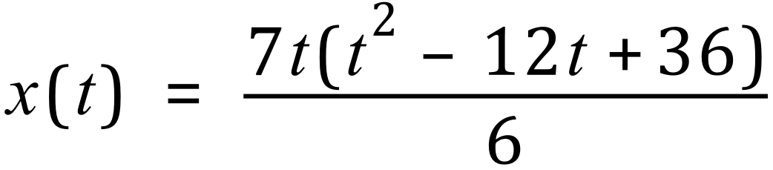 , 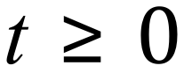 .

(a) Determine the velocity function, , for the particle. (2 marks)

(b) Determine the displacement of the particle at the instant it is stationary. (3 marks)

(c) Determine the acceleration function, 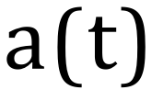 , for the particle. (2 marks)

(d) How far has the particle travelled before its acceleration is zero? (3 marks)

**Question 16 (8 marks)**

A sculpture has a uniform cross-section shown below (indicated by the shaded region) with a width of 3 metres. All measurements are in metres. The equation of the curve is for metres

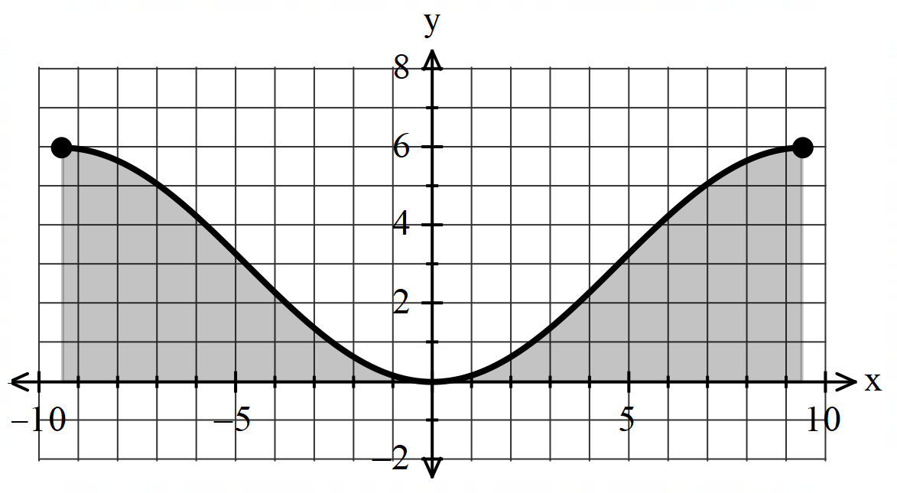

1. Determine the height of the sculpture. (1 mark)
2. Determine the volume of the material making the sculpture. (3 marks)

c) Determine the coordinates of the steepest point(s) on the cross-section. Justify. (4 marks)

Additional working space

Question number: _______

Additional working space

Question number: ________

Additional working space

Question number: ________